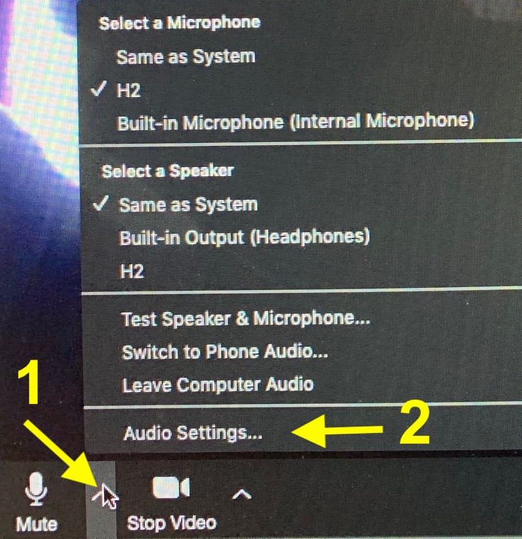
Doing Music Over Zoom
Improving Sound Quality
David Perasso 4 April 2020
When using Zoom to share music, the standard settings and the mic on your laptop or iPhone might not give you the sound quality you want. Here are some things you can do to improve the sound. Most of this requires a laptop or desktop as the options are not available on smart phones..

1 - Update Zoom
Zoom has made some recent changes to it's user interface. Make sure you have the latest version or some of these instructions won't work. Here is a link to instructions on how to check your version: https://support.zoom.us/hc/en-us/articles/201362393-Viewing-the-Zoom-version-number

2 - Microphone
Your sound can never be better than what your mic sends to your computer. Getting a decent audio mic that interfaces to your computer will make a big difference in sound quality.

3 - Enable Original Sound
Enabling original oound will eliminate echo cancellation and greatly improve sound quality. This can only be done on a laptop.
To enable original sound:

1- Enter the zoom meeting

2- move the cursor over the up arrow in the lower left of the screen and click

3- In the pop up, select audio settings.

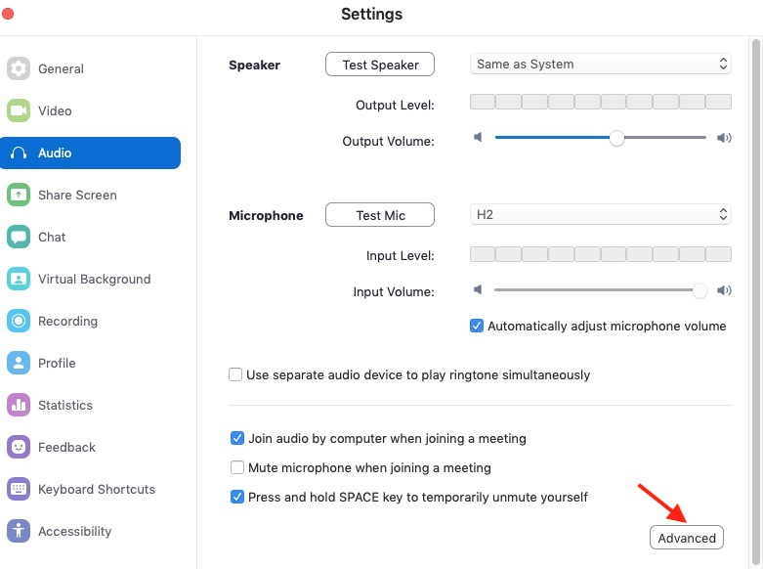
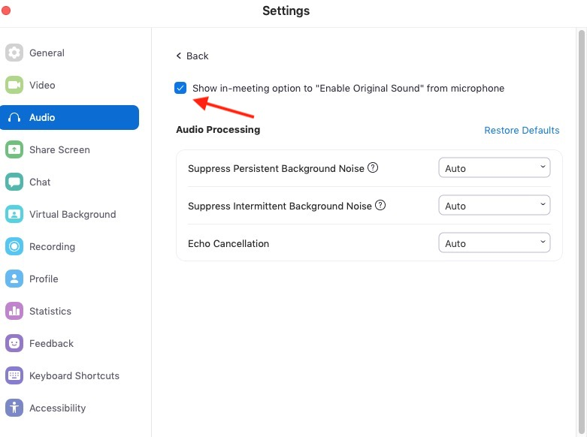
This will bring up the Audio Settings window. Click on Advanced.
This will bring up the advanced page where you can enable the option. Click the box next to Show in-meeting option to "Enable Original Sound" from microphone. You will only need to do this once as it will be remembered in future sessions.
Close the window.
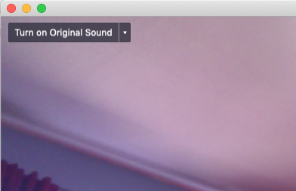
2) Use the option when you are performing
In the upper left corner of your Zoom window you will see an option to "Turn on Original Sound". Clicking this option will enable it, clicking again will disable it. Enable this option during and only during the time you are performing. When you are finished performing, disable the option.

Selecting Your Audio Input
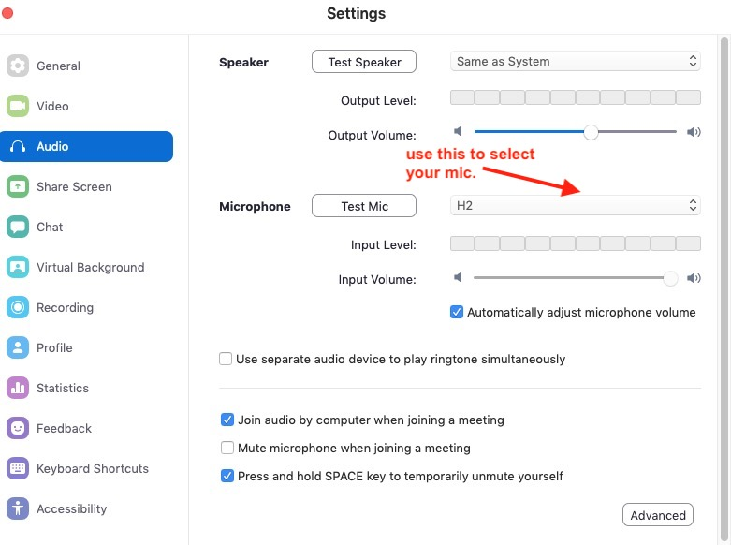
If you have an external mic open the Audio Settings window and select the mic or line input that you want to use:

Adjusting Your Volume
By default Automatically adjust microphone volume is enabled. If you uncheck this option, you can manually adjust your levels.
If you are using your computer mic or the sensitivity of your mic (or mixer) is controllable by your computer, disabling the option will allow you to use the slider to adjust the mic gain. If your computer cannot control the mic gain (this is usually the case with USB mics), you will have to adjust the gain of the mic or mixer using the controls on the mic or mixer.
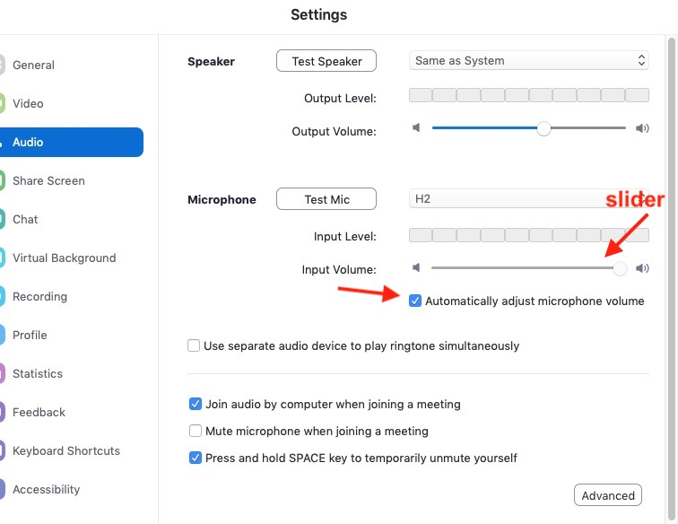

Summary
The exact sequence will vary from event to event, but here is a rough summary of what you can do to improve your sound.

Before the Zoom event:
- Get a mic or mics/mixer that interfaces to your computer. Position it and test it before the event.
- Enable the Enable Original Sound option. You only need to do this once and the option will be displayed whenever you are in a Zoom session.

When you are in the event:
- Unless you are singing or talking to the group, make sure your mic is muted.

When it is your turn to perform:
- Unmute your mic (the host may do this for you).
- With the help of the host, use the controls in the Audio Settings window to set your mic levels. (Skip this if you didn't disable automatic volume control).
- After the host introduces you, click the option in the upper left of your Zoom window to turn preserve original sound on.
- Sing/play your songs
- Click the option in the upper left of your Zoom window to turn preserve original sound off.

